EPPlus

# Dump out

<http://www.pluralsight.com/courses/creating-server-side-excel-workbooks>

### Download Excel



### Export from text file ——LoadFromText

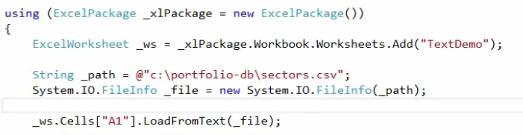

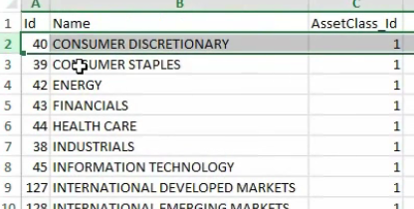

### Export from DataSet——LoadFromDataTable

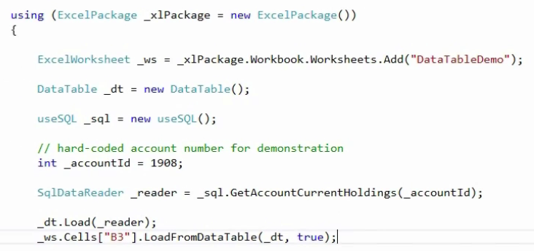

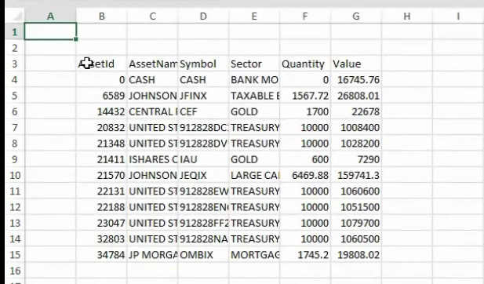

### Export from Array——LoadFromArrays

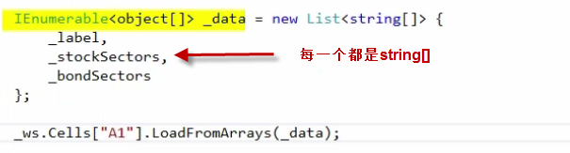

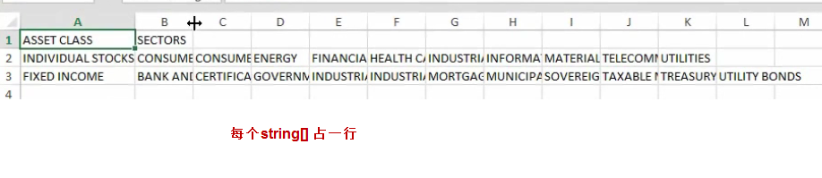

### Export from Collection——LoadFromCollection

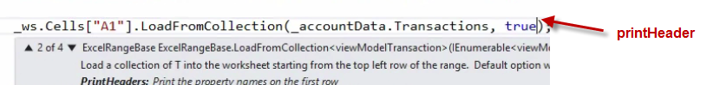

# Styling Excel

### Styling

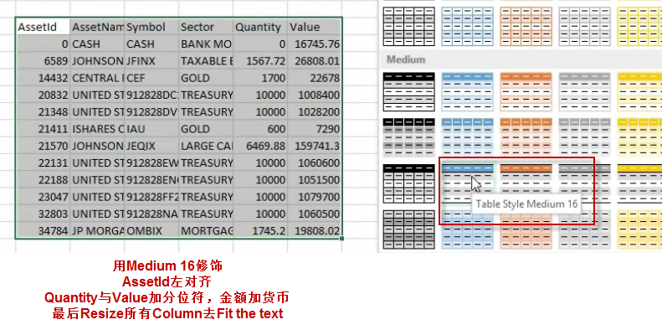

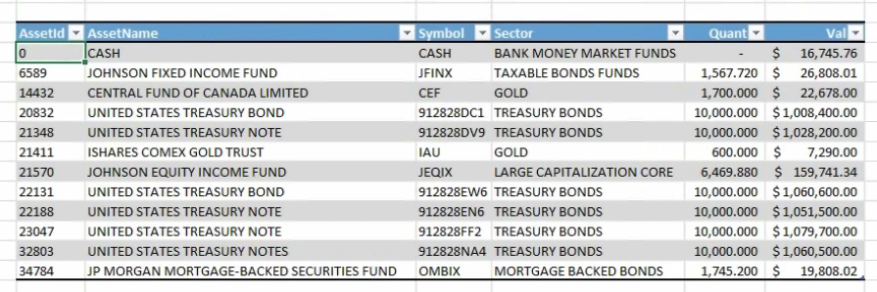

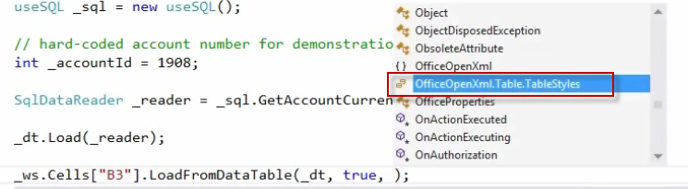

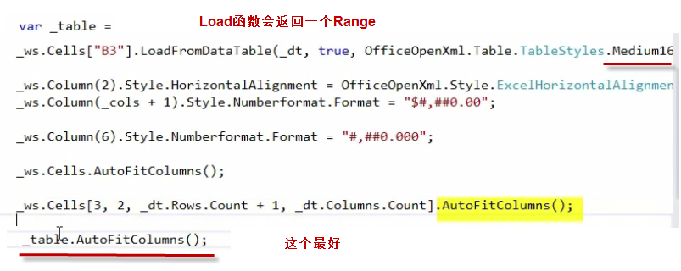

### Exported Table Range

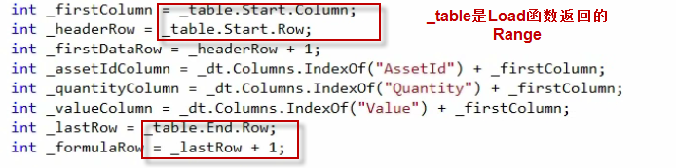

### Functions



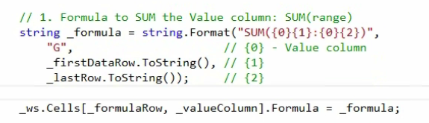

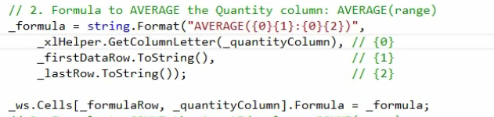

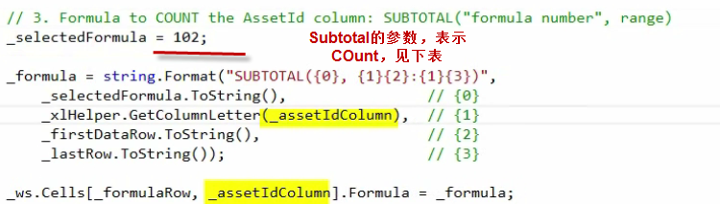

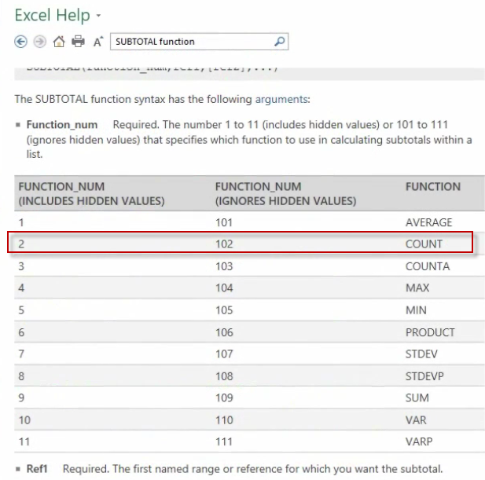

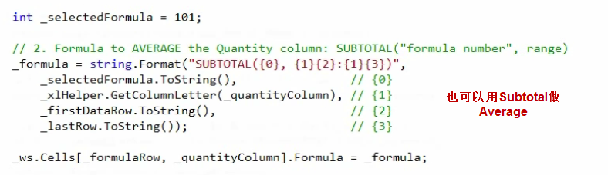

### Excel Column Letter与Index

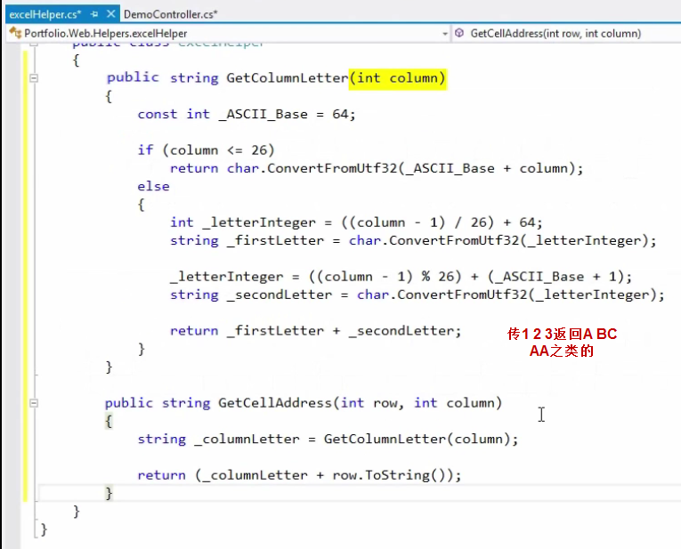

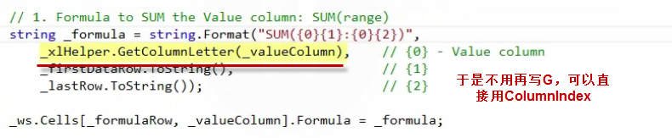

### Controlled Placement

要做这样的东西

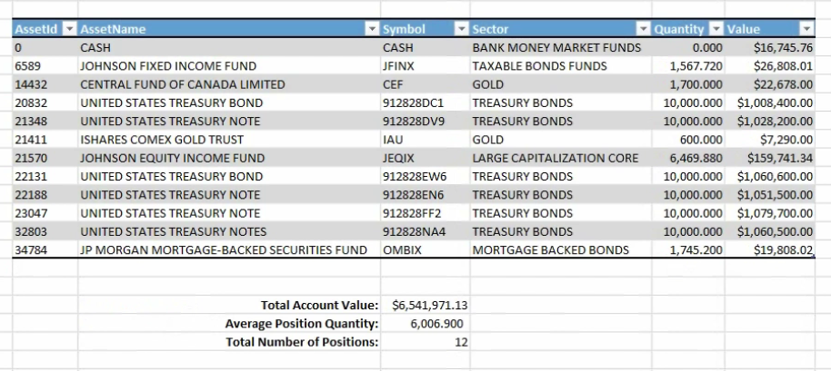



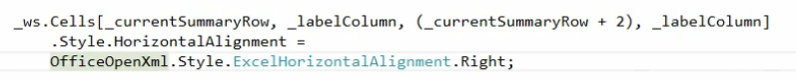



# Template

### Create a template——Worksheet.Names[]

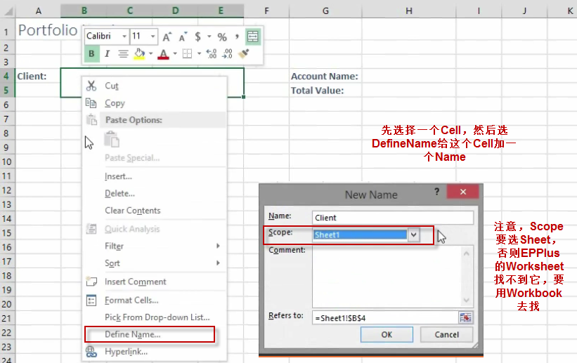

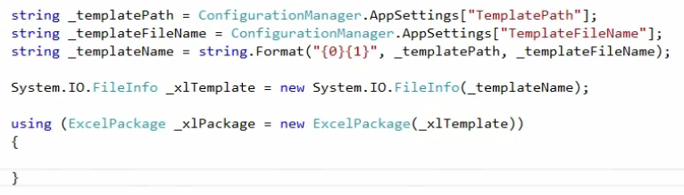

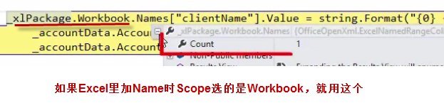

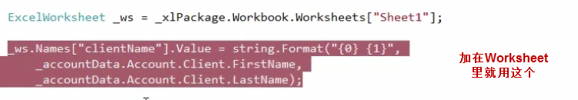

### Create a template——Tables

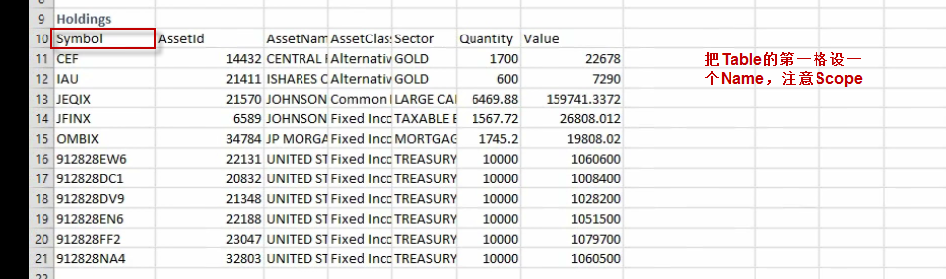

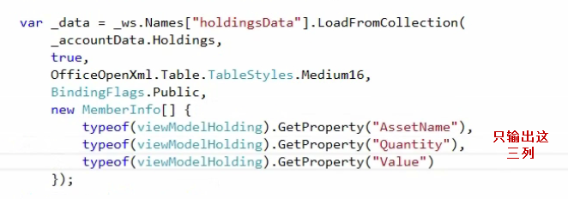

### Filter



# Chart

### Pie

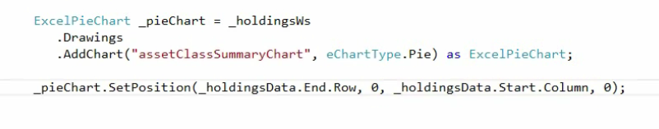

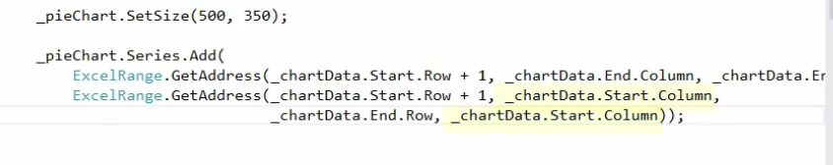

### Image

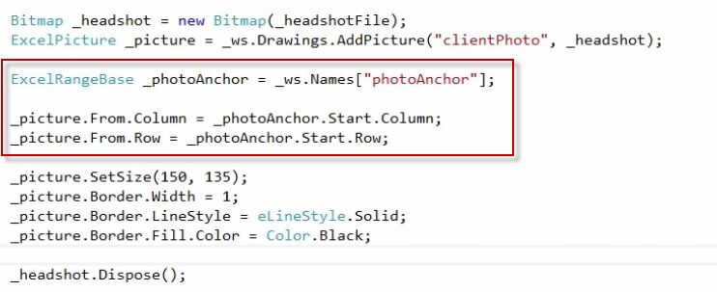

### Comment

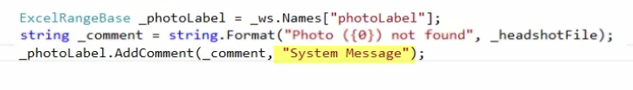

### Shape

